**CONTACT DETAILS**

DATE……………………………..

Customer Name……………………………………….

Address…………………………………………………

……………………………………………………………

E-mail…………………………..……………………….

Phone…………………………

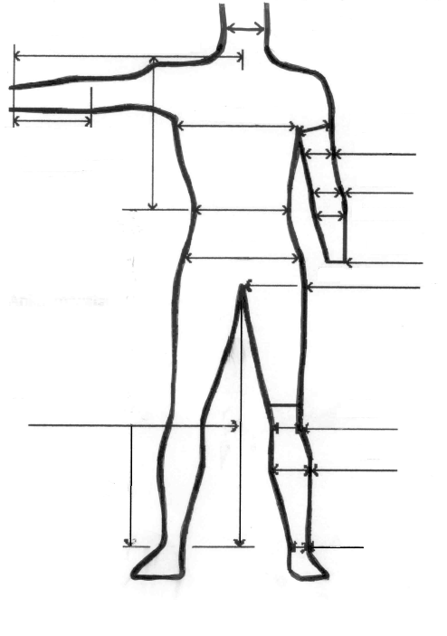

**SUIT DETAILS**

Male Female Junior

Style of Suit…………………………………………………

Material Colour……………………………………………..

Size…………. Height…………… Weight……………….

Other Comments …………………………………………..

………………………………………………………………

………………………………………………………………

………………………………………………………………

………………………………………………………………

………………………………………………………………

………………………………………………………………

………………………………………………………………

Salesperson………………………………………………..

**PAYMENT DETAILS**

Cost of Suit……………… Custom Making Fee………..

Colour Choice Fee………Material Fee………………….

Freight……………… Total Cost………………………….

Deposit………………Balance…………………………..

Credit Card No……………………………..........................

Expiry……………

P.I.F Date: ……………….



**FREIGHT DETAILS**

Delivery Cost…………………

Pick-up

10 NEGARA CRESCENT, GOODWOOD, TASMANIA 7010, AUSTRALIA

Phone: 03 6273 0666 Fax: 03 62730692

Email: enquiries@anchorwetsuits.com.au